Hampshire County Councillor: Annual Report 2022-2023
Budget for 2023-2024
Hampshire County Council’s expenditure for 2023/24 includes a £2.6bn annual revenue budget and covers all the services delivered by the council for 1.4 million residents, including supporting its most vulnerable children and adults.

Capital budget projects totalling £645.3m over the next three years include:
• £175m investment in new and extended school buildings to provide school places for children in Hampshire, giving a total of 18,874 new school places by September 2025.
• £142m for structural maintenance and improvement of roads and bridges.
• £103m of Integrated Transport Plan schemes including £58m of schemes focused on walking and cycling improvements.
• £0.3m funding towards the County Council’s Flood Risk and Coastal Defence Programme as part of our response to the challenge of climate change.

Hampshire County Council’s council tax precept for the financial year beginning 1 April 2023, will increase by a total of 4.99%, of which 2% will go specifically towards adults’ social care, in line with Government policy. This equates to an annual charge of £1,460.25 for a Band D property – an increase of £69.45 per year or approximately £1.34 a week.

Where the budget will be spent

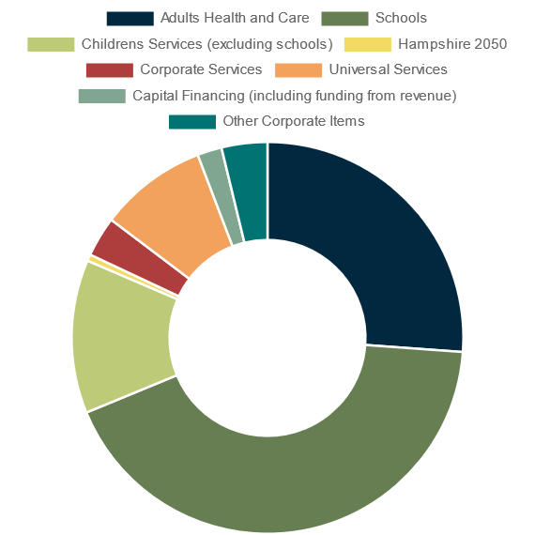

HCC Highlights from 2022/23
Pan-Hampshire County Deal
Council Leader Cllr Rob Humby held discussions with central government on plans for a Pan-Hampshire County Deal, with the aim of investing in Hampshire’s economy and improving the lives of all residents and communities across the area by decentralising key decision making and funding.
England’s Chief Medical Officer Prof Sir Chris Whitty visited Hampshire County Council in March 2023 to discuss work by our Public Health team working alongside the NHS to help support a healthier old age. Preventing falls, being travel confident, better mental health and connecting through libraries will be part of the Live Longer Better programme launching soon. www.hantsiowhealthandcare.org.uk
Short Term Care Hampshire County Council’s Adult Social Care service offers a range of care options to help our residents after a stay in hospital and help them settle back home. For some really good advice and help for older people visit www.connecttosupporthampshire.org.uk
The Chat About Scheme runs across our libraries and other community sites to provide a welcome space in which people can gather to connect and chat. The scheme is free to join and open to groups and organisations, such as libraries, cafés, community and voluntary venues, regular coffee morning gatherings, and workplace canteens.
Hampshire offers 97% of pupils their preferred Choice of School
More than 97% of parents in Hampshire have been offered a place for their child at one of their three preferences for a secondary school in September 2023.
Tree planting gathers pace
Hampshire Forest Partnership has continued to make great strides towards our target of planting one million trees by 2050.
Traffic Management
From 1st April 2023 the county council will take back traffic management (lines and signs!) from the district authorities.
Additional funding for pothole repairs
Confirmed in the government’s Spring Budget, the county council will receive £5,954,400 to tackle this issue. Please report road issues at hants.gov.uk
HCC building a new Materials Recycling Facility in Eastleigh
This will enable the recycling of very many more items, including Tetra Paks and plastics. The site will be fully operational in 2025.
Major investment in Hampshire Schools
A planned investment programme in Hampshire schools of £221m was announced. The programme includes several proposed school expansions; projects for special schools, early years settings and children’s social care; as well as other improvements and modernisation of existing buildings.
20mph zones in Hampshire
The outcomes of the Task and Finish Group on the introduction of 20mph zones has been published. There are a number of recommendations in the report including community support before introducing 20mph zones more widely.
Lengthsman Funding
Funding to Parishes for the Lengthsman Scheme will continue for the coming financial year 2023/24. The Lengthsman scheme is a good example of successful joined-up government in Hampshire.

Energy efficiency programme
Hundreds of public buildings such as schools, libraries and museums have been made more energy efficient thanks to the installation of solar panels, double glazing, and modern heating systems. This follows the completion of an initiative to cut carbon emissions and has helped to mitigate the impact of rising energy costs.
Welcoming Ukrainian families
The county of Hampshire has welcomed the third highest number of Ukrainian nationals in England. The county council will be increasing the payments made to all Hampshire residents hosting Ukrainian guests as part of the Government’s Homes for Ukraine Scheme from £350 to £500 per month from March.
County Councillor Grant
My annual devolved Councillor Grant pot is for projects or events across the Winchester Downlands Division. It was opened on 1st April for Coronation grants and will open again for other applications on 1st June 2023. Please contact me if you have a project or event that will benefit residents. In the meantime, please see the list of projects that benefitted from my grant funding last year:

Councillor Devolved Grants made in the financial year 22/23
Applicant | Project | Grant
Winchester Walking Football | Defibrillator | £333
Winchester Stroke Aphasia Group | Support for group meetings | £250
Sparsholt Parish Hall Committee | Wooden Floor Resurfacing | £400
Hursley Parish Council | Village in Bloom Planters | £300
Wessex Cancer Trust | Counselling Services | £250
Maggie’s Cancer Trust | Hospital Garden room for families | £400
Oliver’s Battery Parish Council | Sustainability Event at Fete | £300
MHA Winchester | Tackling isolation and loneliness in the Elderly | £300
Worthy Down Tri Service Base | Contribution to family event for service personnel | £600
Winchester GoLD (Learning Disability) | Winchester Pantomime Visit
Otterbourne Parish Council | QEII Memorial Garden and Bench | £600
Hursley Village Community Association | Mini Forest Tree Planting | £300
Winchester Beacon (Night Shelter) | Upgrade of bathroom facilities | £1000
Blue Apple Productions | Animal Farm | £250
Badger Farm Community Association | Repair Cafe | £450
Winchester Bereavement Support | Bereavement Counselling Services | £600

Cllr Jan Warwick
Hampshire County Councillor for Winchester Downlands
Winchester City Councillor
Tel: 07717 104236
Email: jan.warwick@hants.gov.uk or jwarwick@winchester.gov.uk

